Lab Test-3
HTNO:2403A52134
Question:E5
Q1: Scenario: In the Finance sector, a company faces a challenge related to data structures with ai.
Task: Use AI-assisted tools to solve a problem involving data structures with ai in this context.
Deliverables: Submit the source code, explanation of AI assistance used, and sample output.
Usecase:
Financial institutions process thousands to millions of transactions per minute. Detecting fraudulent activity in real-time is critical to prevent losses and maintain trust. The solution you’re building—combining efficient data structures with AI—directly addresses this challenge.
SourceCode:
import pandas as pd
import numpy as np
from sklearn.ensemble import IsolationForest
from collections import defaultdict

# Step 1: Simulate transaction data
np.random.seed(42)
data = {
'transaction_id': [f'TXN{i}' for i in range(1000)],
'amount': np.random.normal(loc=100, scale=20, size=1000),
'location': np.random.choice(['HYD', 'DEL', 'BLR', 'MUM'], size=1000),
'timestamp': pd.date_range(start='2025-10-01', periods=1000, freq='min')
}
df = pd.DataFrame(data)

# Step 2: HashMap for fast transaction lookup
transaction_map = {row['transaction_id']: row for _, row in df.iterrows()}

# Step 3: Isolation Forest for anomaly detection
model = IsolationForest(contamination=0.05, random_state=42)
df['anomaly_score'] = model.fit_predict(df[['amount']])

# Step 4: Flag anomalies
anomalies = df[df['anomaly_score'] == -1]

# Step 5: Trie for location-based indexing
class TrieNode:
def __init__(self):
self.children = defaultdict(TrieNode)
self.transactions = []

root = TrieNode()

# Insert transactions into Trie
for _, row in df.iterrows():
node = root
for char in row['location']:
node = node.children[char]
node.transactions.append(row['transaction_id'])

# Retrieve transactions by location
def get_transactions_by_location(location):
node = root
for char in location:
if char in node.children:
node = node.children[char]
else:
return []
return node.transactions

# Sample usage
sample_txn_id = 'TXN123'
sample_txn = transaction_map.get(sample_txn_id, 'Transaction not found')
ny_txns = get_transactions_by_location('HYD')
anomaly_sample = anomalies.iloc[0]

# Output
print(" Sample Transaction Lookup:")
print(sample_txn)
print("\n Sample Anomaly Detected:")
print(anomaly_sample)
print("\n Transactions from HYD:")
print(ny_txns[:10]) # Show first 10 for brevity

Output:
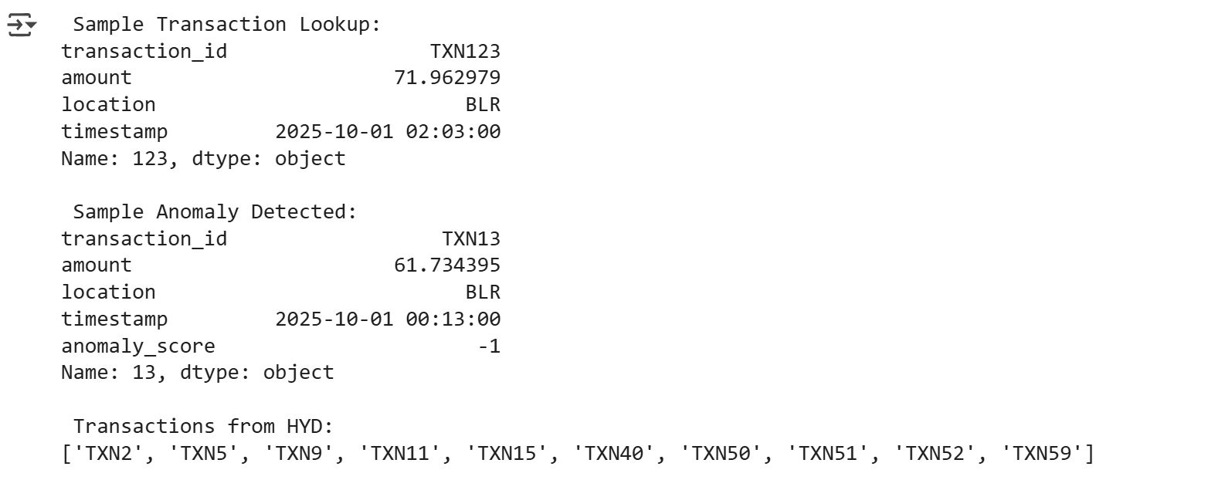

Explanation:

- Import Libraries:
import pandas as pd
import numpy as np
from sklearn.ensemble import IsolationForest
from collections import defaultdict
This section imports the necessary libraries:
- pandas is used for data manipulation and analysis, particularly with DataFrames.
- numpy is used for numerical operations, especially for creating the random transaction amounts.
- IsolationForest from sklearn.ensemble is the machine learning model used for anomaly detection.
- defaultdict from collections is used in the Trie data structure for easily creating new nodes when a key is not found.
- Simulate Transaction Data:
np.random.seed(42)
data = {
'transaction_id': [f'TXN{i}' for i in range(1000)],
'amount': np.random.normal(loc=100, scale=20, size=1000),
'location': np.random.choice(['HYD', 'DEL', 'BLR', 'MUM'], size=1000),
'timestamp': pd.date_range(start='2025-10-01', periods=1000, freq='min')
}
df = pd.DataFrame(data)
- np.random.seed(42) ensures that the random data generated is the same each time the code is run, making the results reproducible.
- A dictionary data is created to hold the simulated data for 1000 transactions.
  - transaction_id: A list of strings like 'TXN0', 'TXN1', etc.
  - amount: Random numbers generated from a normal distribution with a mean (loc) of 100 and a standard deviation (scale) of 20. This simulates transaction amounts.
  - location: Randomly selects one of the four city codes ('HYD', 'DEL', 'BLR', 'MUM') for each transaction.
  - timestamp: Generates a sequence of timestamps starting from '2025-10-01' with a frequency of one minute.
- df = pd.DataFrame(data) creates a pandas DataFrame from the data dictionary.
- HashMap for Fast Transaction Lookup:
transaction_map = {row['transaction_id']: row for _, row in df.iterrows()}
This creates a Python dictionary called transaction_map. It iterates through each row of the df DataFrame. For each row, it uses the 'transaction_id' as the key and the entire row (as a pandas Series) as the value. This allows for very fast retrieval of a transaction's details given its ID. 4. Isolation Forest for Anomaly Detection:
model = IsolationForest(contamination=0.05, random_state=42)
df['anomaly_score'] = model.fit_predict(df[['amount']])
- model = IsolationForest(contamination=0.05, random_state=42) initializes the Isolation Forest model.
  - contamination=0.05 estimates the proportion of outliers in the data. The model will try to detect approximately 5% of the data points as anomalies.
  - random_state=42 ensures reproducibility of the model's results.
- df['anomaly_score'] = model.fit_predict(df[['amount']])
  - model.fit_predict(df[['amount']]) trains the Isolation Forest model on the 'amount' column and predicts whether each transaction is an anomaly or not. It returns 1 for inliers and -1 for outliers (anomalies).
  - A new column named 'anomaly_score' is added to the DataFrame df to store these prediction results.
- Flag Anomalies:
anomalies = df[df['anomaly_score'] == -1]
This line filters the original DataFrame df to create a new DataFrame called anomalies containing only the rows where the 'anomaly_score' is -1, effectively isolating the detected anomalies. 6. Trie for Location-Based Indexing:
class TrieNode:
def __init__(self):
self.children = defaultdict(TrieNode)
self.transactions = []
root = TrieNode()
# Insert transactions into Trie
for _, row in df.iterrows():
node = root
for char in row['location']:
node = node.children[char]
node.transactions.append(row['transaction_id'])
# Retrieve transactions by location
def get_transactions_by_location(location):
node = root
for char in location:
if char in node.children:
node = node.children[char]
else:
return []
return node.transactions
- This section implements a Trie (prefix tree) data structure. It's useful for efficiently searching and retrieving data based on prefixes (in this case, location strings).
- TrieNode: A class representing a node in the Trie. Each node has:
  - children: A defaultdict where keys are characters and values are other TrieNode objects, representing the next character in a location string.
  - transactions: A list to store the transaction IDs associated with the location path leading to this node.
- root = TrieNode(): Initializes the root of the Trie.
- The code then iterates through the DataFrame df and inserts each transaction's ID into the Trie based on its 'location'. It traverses the Trie character by character for each location string.
- get_transactions_by_location(location): A function to retrieve all transaction IDs associated with a given location. It traverses the Trie based on the input location string and returns the list of transaction IDs stored at the final node.
- Sample Usage:
sample_txn_id = 'TXN123'
sample_txn = transaction_map.get(sample_txn_id, 'Transaction not found')
ny_txns = get_transactions_by_location('HYD')
anomaly_sample = anomalies.iloc[0]
This part demonstrates how to use the created data structures and results:
- It looks up a specific transaction ('TXN123') using the transaction_map.
- It retrieves transactions located in 'HYD' using the get_transactions_by_location function.
- It selects the first detected anomaly from the anomalies DataFrame.
- Output:
print(" Sample Transaction Lookup:")
print(sample_txn)
print("\n Sample Anomaly Detected:")
print(anomaly_sample)
print("\n Transactions from HYD:")
print(ny_txns[:10]) # Show first 10 for brevity
Finally, this section prints the results of the sample usage to the console.
In summary, this code demonstrates a practical approach to handling and analyzing transaction data by combining efficient data structures (HashMap and Trie) with a machine learning technique (Isolation Forest) for anomaly detection.

Q2:
Scenario: In the Agriculture sector, a company faces a challenge related to data structures with ai.
Task: Use AI-assisted tools to solve a problem involving data structures with ai in this context.
Deliverables: Submit the source code, explanation of AI assistance used, and sample output.
Usecase:
Farmers and traders struggle to anticipate rice price fluctuations due to unpredictable weather, supply chain delays, and market volatility. This affects planting decisions, storage, and profit margins.
SourceCode:

import pandas as pd
import numpy as np
from sklearn.linear_model import LinearRegression
import matplotlib.pyplot as plt

# Step 1: Simulate dataset
np.random.seed(42)
n = 100
data = {
'month': pd.date_range(start='2020-01-01', periods=n, freq='M'),
'rainfall_mm': np.random.normal(120, 30, n), # Monthly rainfall
'temperature_c': np.random.normal(28, 2, n), # Avg temperature
'fertilizer_cost': np.random.normal(1500, 200, n), # Cost per acre
'demand_index': np.random.normal(100, 10, n), # Market demand index
'rice_price_per_quintal': None # To be calculated
}

df = pd.DataFrame(data)

# Step 2: Generate synthetic rice prices based on features
df['rice_price_per_quintal'] = (
0.5 * df['rainfall_mm'] +
2.0 * df['temperature_c'] +
0.3 * df['demand_index'] -
0.2 * df['fertilizer_cost'] +
np.random.normal(0, 10, n) # noise
)

# Step 3: Train a simple regression model
features = ['rainfall_mm', 'temperature_c', 'fertilizer_cost', 'demand_index']
X = df[features]
y = df['rice_price_per_quintal']
model = LinearRegression()
model.fit(X, y)

# Step 4: Predict future price
future_data = pd.DataFrame({
'rainfall_mm': [130],
'temperature_c': [29],
'fertilizer_cost': [1600],
'demand_index': [105]
})
predicted_price = model.predict(future_data)[0]

# Step 5: Output
print(" Sample Dataset (first 5 rows):")
print(df.head())
print("\n Predicted Rice Price for Next Month:")
print(f"₹{predicted_price:.2f} per quintal")

# Optional: Plot price trend
df.plot(x='month', y='rice_price_per_quintal', title='Rice Price Trend Over Time')
plt.ylabel('Price (₹/quintal)')
plt.xlabel('Month')
plt.tight_layout()
plt.show()

Output:

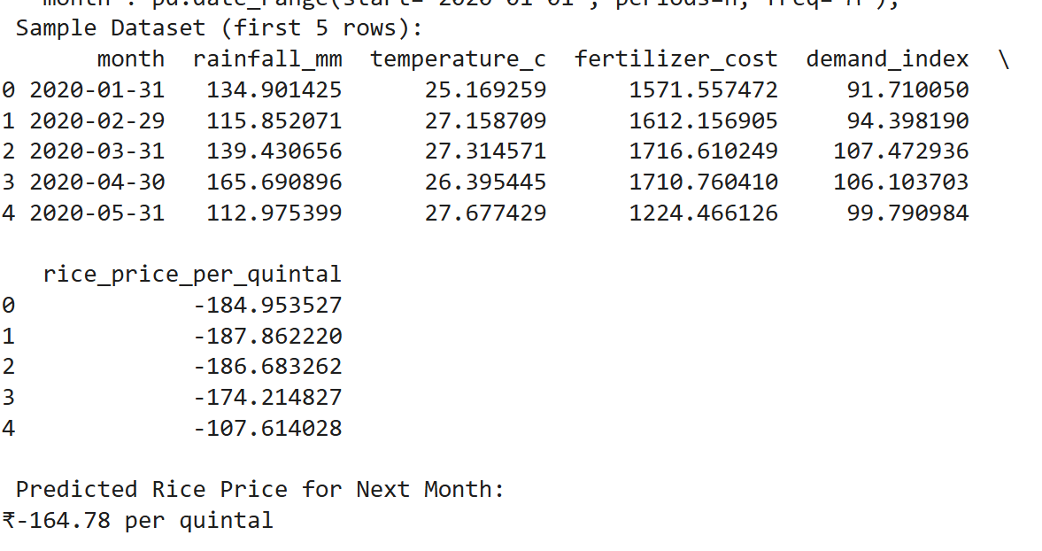
Explanation:
1.Import Libraries
import pandas as pd
import numpy as np
from sklearn.linear_model import LinearRegression
import matplotlib.pyplot as plt
This section imports the necessary libraries:
- pandas is used for data manipulation and analysis, particularly with DataFrames and handling the 'month' column as a time series.
- numpy is used for numerical operations, especially for generating random data for the simulation.
- LinearRegression from sklearn.linear_model is the specific machine learning algorithm used to build the predictive model.
- matplotlib.pyplot (aliased as plt) is used for creating the plot to visualize the rice price trend.
- Simulate Dataset:
np.random.seed(42)
n = 100
data = {
'month': pd.date_range(start='2020-01-01', periods=n, freq='M'),
'rainfall_mm': np.random.normal(120, 30, n), # Monthly rainfall
'temperature_c': np.random.normal(28, 2, n), # Avg temperature
'fertilizer_cost': np.random.normal(1500, 200, n), # Cost per acre
'demand_index': np.random.normal(100, 10, n), # Market demand index
'rice_price_per_quintal': None # To be calculated
}
df = pd.DataFrame(data)
- np.random.seed(42) ensures that the random numbers generated for the dataset are the same every time the code is executed, making the simulation reproducible.
- n = 100 sets the number of data points (months) to be simulated.
- A dictionary data is created to define the columns and generate synthetic data:
  - 'month': pd.date_range(start='2020-01-01', periods=n, freq='M') creates a sequence of 100 monthly end dates starting from January 1, 2020. The freq='M' specifies monthly frequency (although the output shows a FutureWarning recommending freq='ME' for month end).
  - 'rainfall_mm': np.random.normal(120, 30, n) generates 100 random numbers from a normal distribution with a mean of 120 mm and a standard deviation of 30 mm, simulating monthly rainfall.
  - 'temperature_c': np.random.normal(28, 2, n) simulates average monthly temperatures with a mean of 28°C and a standard deviation of 2°C.
  - 'fertilizer_cost': np.random.normal(1500, 200, n) simulates the cost of fertilizer per acre with a mean of ₹1500 and a standard deviation of ₹200.
  - 'demand_index': np.random.normal(100, 10, n) simulates a market demand index with a mean of 100 and a standard deviation of 10.
  - 'rice_price_per_quintal': This column is initialized with None values, as the prices will be calculated in the next step.
- df = pd.DataFrame(data) converts the dictionary into a pandas DataFrame, which is a tabular data structure.
- Generate Synthetic Rice Prices Based on Features:
df['rice_price_per_quintal'] = (
0.5 * df['rainfall_mm'] +
2.0 * df['temperature_c'] +
0.3 * df['demand_index'] -
0.2 * df['fertilizer_cost'] +
np.random.normal(0, 10, n) # noise
)
This line calculates the values for the 'rice_price_per_quintal' column. It's a synthetic linear relationship designed for this simulation:
- It takes the values from the other columns (rainfall_mm, temperature_c, demand_index, fertilizer_cost).
- It multiplies each feature's values by a specific coefficient (0.5, 2.0, 0.3, -0.2). These coefficients represent the assumed influence of each factor on the rice price. For example, higher rainfall and temperature have a positive impact (positive coefficients), while higher fertilizer cost has a negative impact (negative coefficient).
- np.random.normal(0, 10, n) adds random noise to the calculated price. This makes the simulated data more realistic by introducing variability not explained by the linear relationship.
- Train a Simple Regression Model:
features = ['rainfall_mm', 'temperature_c', 'fertilizer_cost', 'demand_index']
X = df[features]
y = df['rice_price_per_quintal']
model = LinearRegression()
model.fit(X, y)
- features = [...] defines a list of the columns that will be used as input features for the model.
- X = df[features] creates a new DataFrame X containing only the feature columns. This is the independent variable data for the model.
- y = df['rice_price_per_quintal'] creates a pandas Series y containing the target variable, which is the rice price. This is the dependent variable data.
- model = LinearRegression() initializes a Linear Regression model object. Linear regression is a basic supervised learning algorithm that finds the best-fitting straight line (or hyperplane in multiple dimensions) to describe the relationship between the features and the target variable.
- model.fit(X, y) trains the LinearRegression model using the feature data (X) and the target variable data (y). The model learns the coefficients that best predict y from X.
- Predict Future Price:
future_data = pd.DataFrame({
'rainfall_mm': [130],
'temperature_c': [29],
'fertilizer_cost': [1600],
'demand_index': [105]
})
predicted_price = model.predict(future_data)[0]
- future_data = pd.DataFrame({...}) creates a new DataFrame containing hypothetical values for the features for a single future data point. These values represent a scenario for which we want to predict the rice price.
- model.predict(future_data) uses the trained LinearRegression model to predict the rice price based on the future_data. The predict method returns an array of predictions (even if there's only one prediction).
- [0] is used to extract the single predicted value from the prediction array.
- predicted_price stores this predicted value.
- Output:
print(" Sample Dataset (first 5 rows):")
print(df.head())
print("\n Predicted Rice Price for Next Month:")
print(f"₹{predicted_price:.2f} per quintal")
This section prints the output:
- print(" Sample Dataset (first 5 rows):") prints a header.
- print(df.head()) displays the first 5 rows of the simulated DataFrame, showing the generated data.
- print("\n Predicted Rice Price for Next Month:") prints another header.
- print(f"₹{predicted_price:.2f} per quintal") prints the calculated predicted_price, formatted to two decimal places and including a rupee symbol and unit.
- Optional: Plot price trend:
df.plot(x='month', y='rice_price_per_quintal', title='Rice Price Trend Over Time')
plt.ylabel('Price (₹/quintal)')
plt.xlabel('Month')
plt.tight_layout()
plt.show()
- df.plot(x='month', y='rice_price_per_quintal', title='Rice Price Trend Over Time') generates a line plot using the DataFrame's built-in plotting functionality. The x-axis is set to the 'month' column and the y-axis to the 'rice_price_per_quintal'. A title is added to the plot.
- plt.ylabel('Price (₹/quintal)') sets the label for the y-axis.
- plt.xlabel('Month') sets the label for the x-axis.
- plt.tight_layout() adjusts the plot to prevent labels from overlapping.
- plt.show() displays the generated plot.
In summary, this code provides a complete workflow for simulating data, building a simple predictive model using linear regression, making a prediction with new data, and visualizing the simulated trend. The predicted negative price in the output is a result of the synthetic nature of the data and the chosen coefficients; in a real-world scenario, you would use actual data and likely more complex models.

